CSE520
Samuel Marrujo
Professor Yu
Lab 08

Draw two particles going opposite directions using GLSL

In this lab, we are to create 2 particles with different directions using the vertex and fragment shaders. I have successfully completed this task, and here are pictures of the following:

I decided to put some extra effort and did the following:

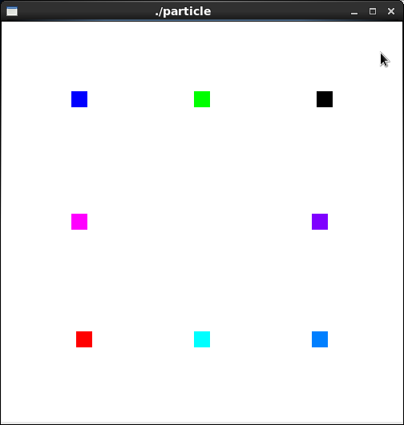
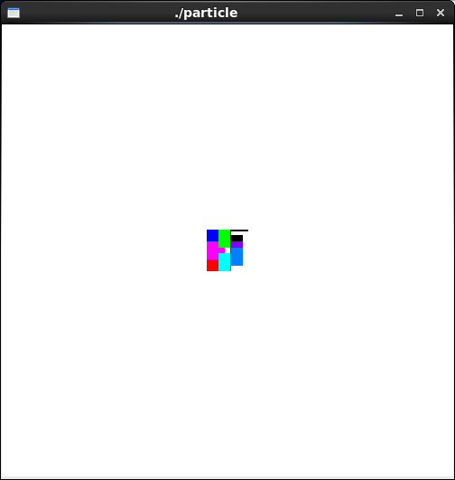
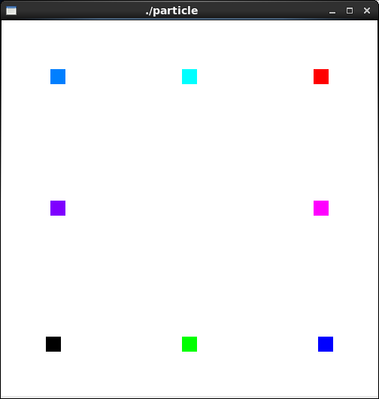
/*
particlie.cpp
Sample program showing how to write GL shader programs.
Shader sources are in files "particle.vert" and "tests.frag".
@Author: T.L. Yu, 2009
*/
#include <stdlib.h>
#include <stdio.h>
#include <string.h>
#include <fcntl.h>
#include <sys/types.h>
#include <unistd.h>

#define GLEW_STATIC 1
#include <GL/glew.h>
#include <GL/glu.h>
#include <GL/glut.h>

using namespace std;

/*
Global handles for the currently active program object, with its two shader objects
*/
GLuint programObject = 0;
GLuint vertexShaderObject = 0;
GLuint fragmentShaderObject = 0;
static GLint win = 0;

GLuint timeParam; //parameters for sending to vertex shader
GLuint velParam; //parameters for sending to vertex shader

int readShaderSource(char *fileName, GLchar **shader )
{
// Allocate memory to hold the source of our shaders.
FILE *fp;
int count, pos, shaderSize;

fp = fopen( fileName, "r");
if ( !fp )
return 0;

pos = (int) ftell ( fp );
fseek ( fp, 0, SEEK_END ); //move to end
shaderSize = ( int ) ftell ( fp ) - pos; //calculates file size
fseek ( fp, 0, SEEK_SET ); //rewind to beginning

if ( shaderSize <= 0 ){
printf("Shader %s empty\n", fileName);
return 0;
}

*shader = (GLchar *) malloc( shaderSize + 1);

// Read the source code

count = (int) fread(*shader, 1, shaderSize, fp);
(*shader)[count] = '\0';

if (ferror(fp))
count = 0;

fclose(fp);

return 1;
}

// public
int installShaders(const GLchar *vertex, const GLchar *fragment)
{
GLint vertCompiled, fragCompiled; // status values
GLint linked;

// Create a vertex shader object and a fragment shader object

vertexShaderObject = glCreateShader(GL_VERTEX_SHADER);
fragmentShaderObject = glCreateShader(GL_FRAGMENT_SHADER);

// Load source code strings into shaders, compile and link

glShaderSource(vertexShaderObject, 1, &vertex, NULL);
glShaderSource(fragmentShaderObject, 1, &fragment, NULL);

glCompileShader(vertexShaderObject);
glGetShaderiv(vertexShaderObject, GL_COMPILE_STATUS, &vertCompiled);

glCompileShader( fragmentShaderObject );
glGetShaderiv( fragmentShaderObject, GL_COMPILE_STATUS, &fragCompiled);

if (!vertCompiled || !fragCompiled)
return 0;

// Create a program object and attach the two compiled shaders

programObject = glCreateProgram();
glAttachShader( programObject, vertexShaderObject);
glAttachShader( programObject, fragmentShaderObject);

// Link the program object

glLinkProgram(programObject);
glGetProgramiv(programObject, GL_LINK_STATUS, &linked);

if (!linked)
return 0;

// Install program object as part of current state

glUseProgram(programObject);

//check log
GLchar log[1000];
GLsizei len;
glGetShaderInfoLog(vertexShaderObject, 1000, &len, log);
printf("Vert Shader Info Log: %s\n", log);
glGetProgramInfoLog(programObject, 1000, &len, log);
printf("Program Info Log: %s\n", log);

return 1;
}

int init(void)
{

const char *version;
GLchar *VertexShaderSource, *FragmentShaderSource;
int loadstatus = 0;

version = (const char *) glGetString(GL_VERSION);
if (version[0] != '2' || version[1] != '.') {
printf("This program requires OpenGL 2.x, found %s\n", version);
// exit(1);
}
readShaderSource( (char *) "particle.vert", &VertexShaderSource );
readShaderSource((char *) "tests.frag", &FragmentShaderSource );
loadstatus = installShaders(VertexShaderSource, FragmentShaderSource);

timeParam = glGetUniformLocation ( programObject, "time" );
velParam = glGetAttribLocation ( programObject, "vel" );
return loadstatus;
}

static void Reshape(int width, int height)
{
glViewport(0, 0, width, height);
glMatrixMode(GL_PROJECTION);
glLoadIdentity();
glFrustum(-5.0, 5.0, -5.0, 5.0, 5.0, 25.0);
glMatrixMode(GL_MODELVIEW);
glLoadIdentity();
glTranslatef(0.0f, 0.0f, -15.0f);
}

void CleanUp(void)
{
glDeleteShader(vertexShaderObject);
glDeleteShader(fragmentShaderObject);
glDeleteProgram(programObject);
glutDestroyWindow(win);
}

static void Idle(void)
{
float t = glutGet ( GLUT_ELAPSED_TIME );
while ( t > 1800 ) t -= 1800;
glUniform1f( timeParam, t );
glutPostRedisplay();
}

static void Key(unsigned char key, int x, int y)
{
switch(key) {
case 27:
CleanUp();
exit(0);
break;
}
glutPostRedisplay();
}

void display(void)
{
GLfloat vec[4];
int loc = glGetAttribLocation(programObject, "temp");
glClear(GL_COLOR_BUFFER_BIT | GL_DEPTH_BUFFER_BIT);
glClearColor(1.0, 1.0, 1.0, 0.0); //get white background color
glColor3f(1, 0, 0); //red, this will have no effect if shader is loaded
glPointSize(20);
//"shoot" a particle at 45 degrees
glBegin (GL_POINTS); //need "GL_POINTS"; "GL_POINT" does not work
glVertexAttrib3f(velParam, 20, 30, 0 ); //send vel to vertex shader
glVertexAttrib3f(loc, 1, 0, 0 );
glVertex2f (-15, -15); //starting position of particle
glEnd();
glBegin(GL_POINTS);
glVertexAttrib3f(velParam, 20, -10, 0);
glVertexAttrib3f(loc, 0, 0, 1);
glVertex2f(-15, 15);
glEnd();
glBegin(GL_POINTS);
glVertexAttrib3f(velParam, 20, 10, 0);
glVertexAttrib3f(loc, 1, 0, 1);
glVertex2f(-15, 0);
glEnd();
glBegin(GL_POINTS);
glVertexAttrib3f(velParam, 0, 30, 0);
glVertexAttrib3f(loc, 0, 1, 1);
glVertex2f(0, -15);
glEnd();
glBegin(GL_POINTS);
glVertexAttrib3f(velParam, 0, -10, 0);
glVertexAttrib3f(loc, 0, 1, 0);
glVertex2f(0, 15);
glEnd();
glBegin(GL_POINTS);
glVertexAttrib3f(velParam, -20, -10, 0);
glVertexAttrib3f(loc, 0, 0, 0);
glVertex2f(15, 15);
glEnd();
glBegin(GL_POINTS);
glVertexAttrib3f(velParam, -20, 10, 0);
glVertexAttrib3f(loc, 0.5, 0, 1);
glVertex2f(15, 0);
glEnd();
glBegin(GL_POINTS);
glVertexAttrib3f(velParam, -20, 30, 0);
glVertexAttrib3f(loc, 0, 0.5, 1);
glVertex2f(15, -15);
glEnd();
glutSwapBuffers();
glFlush();

}

int main(int argc, char *argv[])
{
int success = 0;

glutInit(&argc, argv);
glutInitWindowPosition( 0, 0);
glutInitWindowSize(500, 500);
glutInitDisplayMode(GLUT_RGB | GLUT_DOUBLE | GLUT_DEPTH);
win = glutCreateWindow(argv[0]);
glutReshapeFunc(Reshape);
glutKeyboardFunc(Key);
glutDisplayFunc(display);
glutIdleFunc(Idle);

// Initialize the "OpenGL Extension Wrangler" library
glewInit();

success = init();
if ( success )
glutMainLoop();
return 0;
}
vertex shader:
//particle.vert

uniform float time; //value provided by application program
attribute vec3 vel; //value provided by application program
attribute vec3 temp;
varying vec3 color;

void main(void)
{
color = temp;
float s = 1000.0; //scale factor
float g = -10.0;
float t;
t = time / s; //time in ms
vec4 object_pos = gl_Vertex; //starting position
vec4 object2_pos = gl_Vertex;

object_pos.x = object_pos.x + vel.x*t;
object_pos.y = object_pos.y + vel.y*t + g/2*t*t;
object_pos.z = object_pos.z + vel.z*t;

gl_Position = gl_ModelViewProjectionMatrix * object_pos;

}
frag shader:
//tests.frag
//a minimal fragment shader
varying vec3 color;

void main(void)
{
gl_FragColor = vec4( color, 1 );
//gl_FragColor = vec3( 0, 0, 1); // vec3 no longer works
//gl_FragColor = vec3( 1, 0, 0); //red color
}

